

CRIC CEYLON

07 Nights | 08 Days

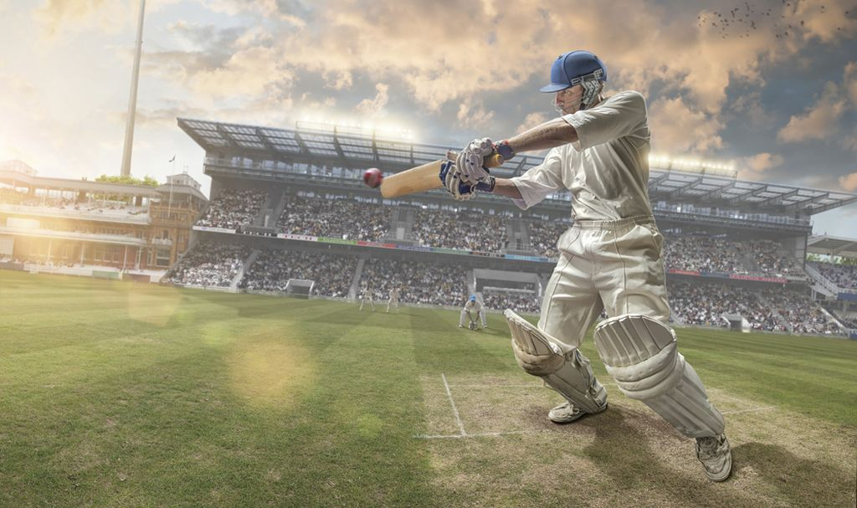

DAY 01 Airport – Colombo CITY

(35 Km 45Mnts)

* Welcome at the Airport.
* Transfer to Colombo.
* Check – in at the Hotel.
* Relax & Leisure at the Hotel.
* Overnight Stay at Hotel in Colombo.

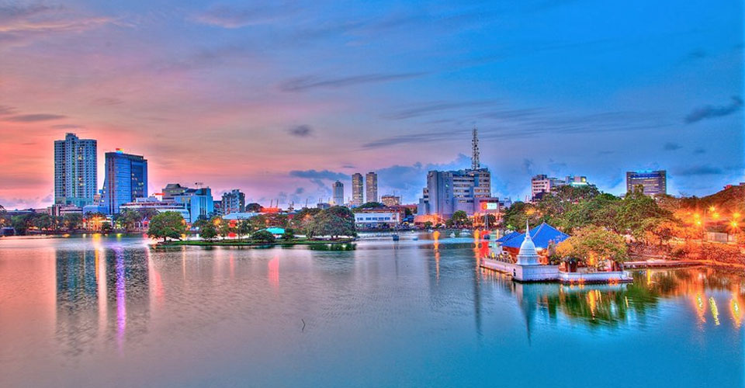**COLOMBO –** The capital of Sri Lanka has a long history as a port on ancient east-west trade routes, ruled successively by the Portuguese, Dutch and British. That heritage is reflected in its architecture, mixing colonial buildings with high-rises and shopping malls. The imposing Colombo National Museum, dedicated to Sri Lankan history, borders sprawling Viharamahadevi Park and its giant Buddha.

DAY 02 Colombo PRACTICE SESSIONS

* Breakfast at Hotel.
* Join the practice sessions arranged in Colombo.
* Return to the Hotel / Own arrangements in Colombo.
* Overnight Stay at Hotel in Colombo.

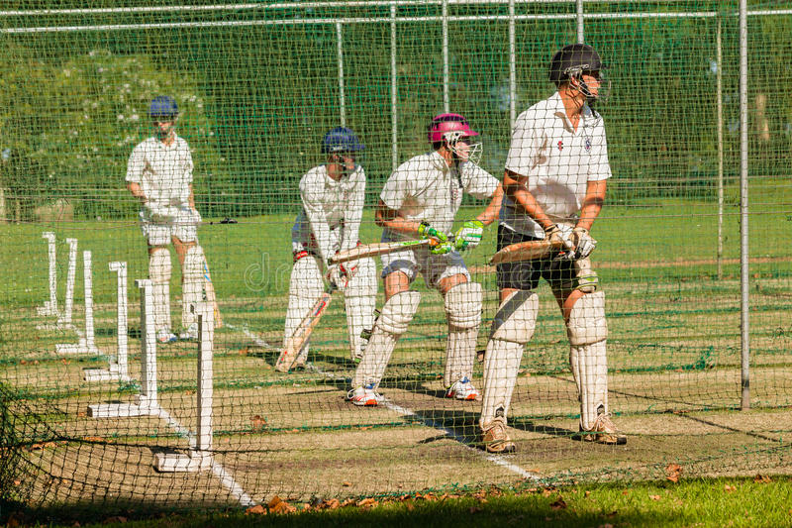

DAY 03 Colombo MATCH 01

* Breakfast at Hotel.
* Leave for the match venue.
* Commence the 01st match of the series.
* Lunch Break.
* Continue with the second session of the game.
* End of the match 01 played in Colombo.
* 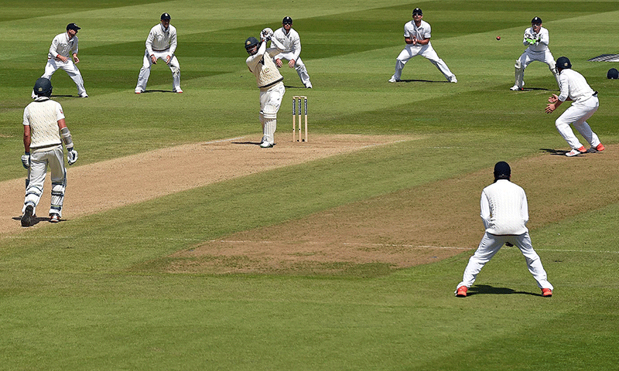Overnight Stay at Hotel in Colombo.

DAY 04 Colombo – Pinnawala –Kandy

(135 Km 5Hrs) GIANTS | KINGDOM

* Breakfast at Hotel.
* Leave Kandy via Pinnawala.
* Visit Elephant orphanage Pinnawala.
* Check – in at hotel in Kandy.
* Evening Sightseeing
* 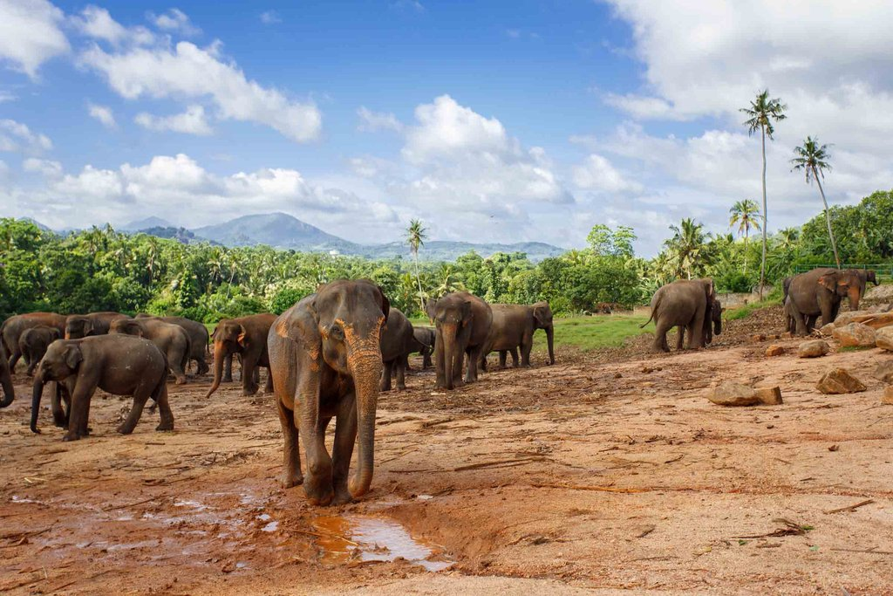Overnight stay at Hotel in Kandy.

Sightseeing

* Pinnawala Elephant Orphanage.
* Temple of the Tooth Relic.
* Gem Museum.
* Cultural Show.

DAY 05 Kandy MATCH 02

* Breakfast at Hotel.
* Leave for the match venue.
* Commence the 02nd match of the series.
* Lunch Break.
* Continue with second the session of the game.
* End of the 02nd match played in Kandy.
* 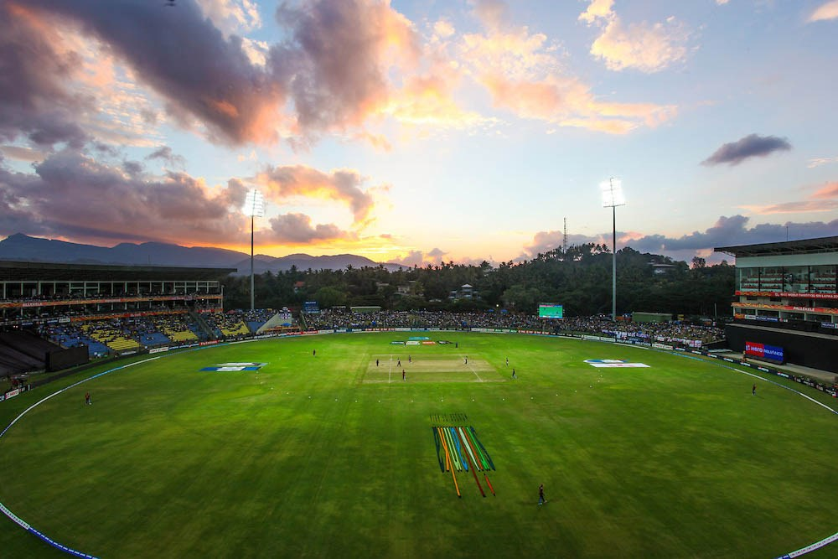Overnight stay at Hotel in Kandy.

DAY 06 Kandy – Peradeniya – Nuwaraeliya

(100 Km 3Hrs) MISTY HILLS

* Breakfast at Hotel.
* Check – out and proceed to visit the Royal Botanical Garden.
* Proceed to Nuwaraeliya, En route visit waterfalls & Tea Factory.
* Check – in at the hotel in Nuwaraeliya.
* 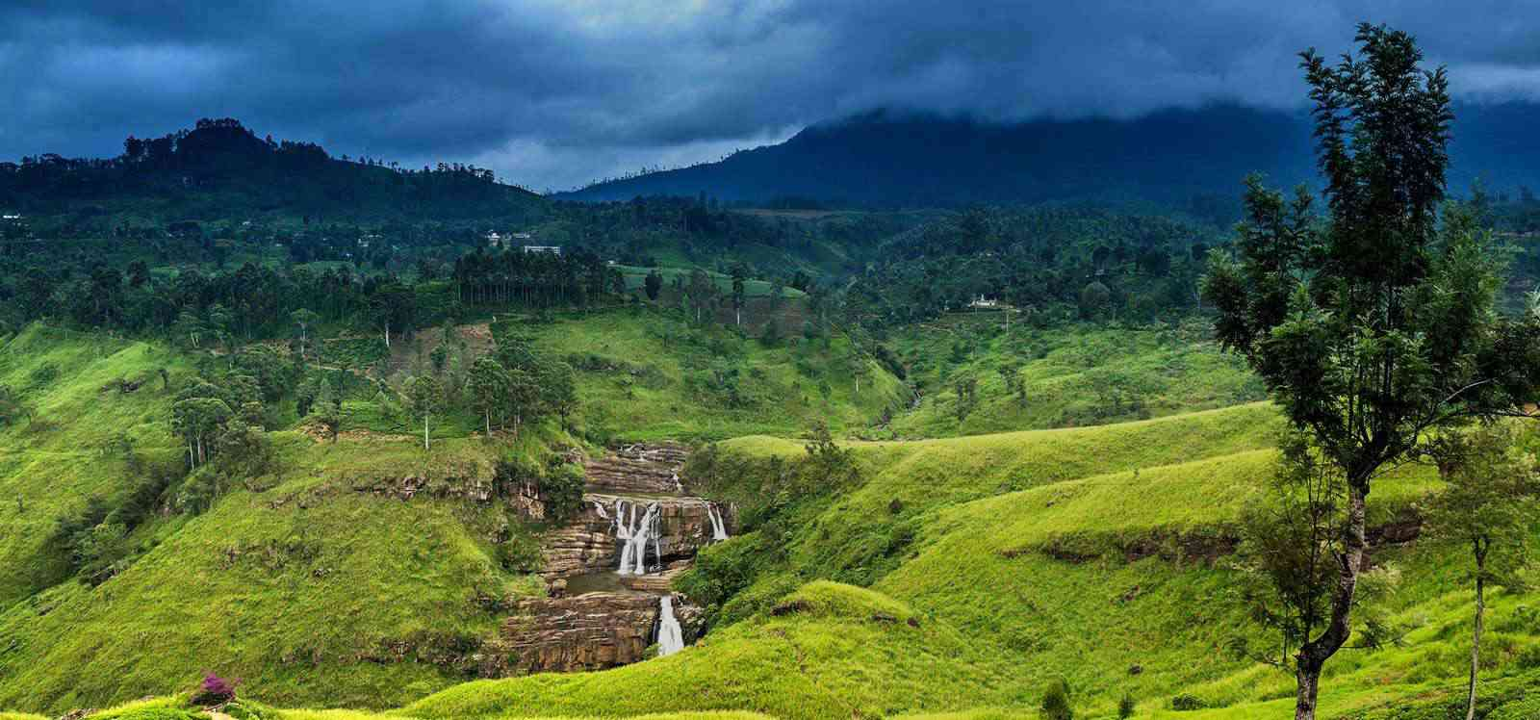Overnight Stay at Hotel in Nuwaraeliya.

Sightseeing

* Botanical Garden.
* En route Waterfalls | Tea Factory.
* Gregory Lake.
* Race Course.
* Golf Course.

DAY 07 Nuwaraeliya – Kitulgala – Bentota

(230Km 6Hrs) RAFTING | BEACH

* Breakfast at Hotel.
* Transfer to Bentota via Kitulgala.
* Kitulgala White Water Rafting. OPTIONAL
* Arrive and Check – in at the hotel in Bentota.
* 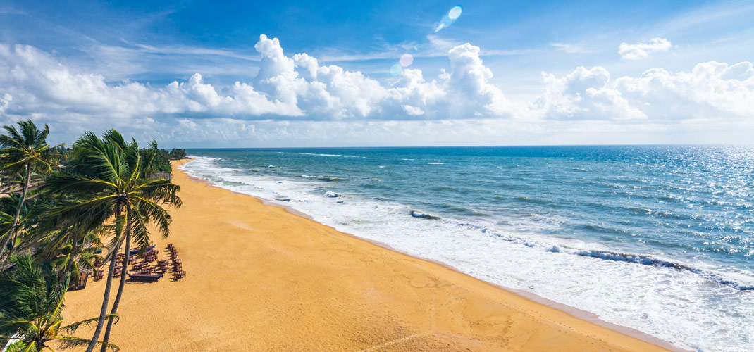Overnight Stay at Hotel in Bentota.

Sightseeing

* Kitulgala Water Rafting. OPTIONAL
* Turtle Hatchery.
* Mangrove boat ride.
* Water Sports. OPTIONAL

DAY 08 Bentota – Colombo – Airport

(110 Km 02Hrs) CITY TOUR |DEPARTURE

* Breakfast at Hotel.
* Check – out and leave for Colombo.
* Arrive in Colombo and commence Sightseeing tour of the city.
* Proceed to Airport for the departure flight.
* 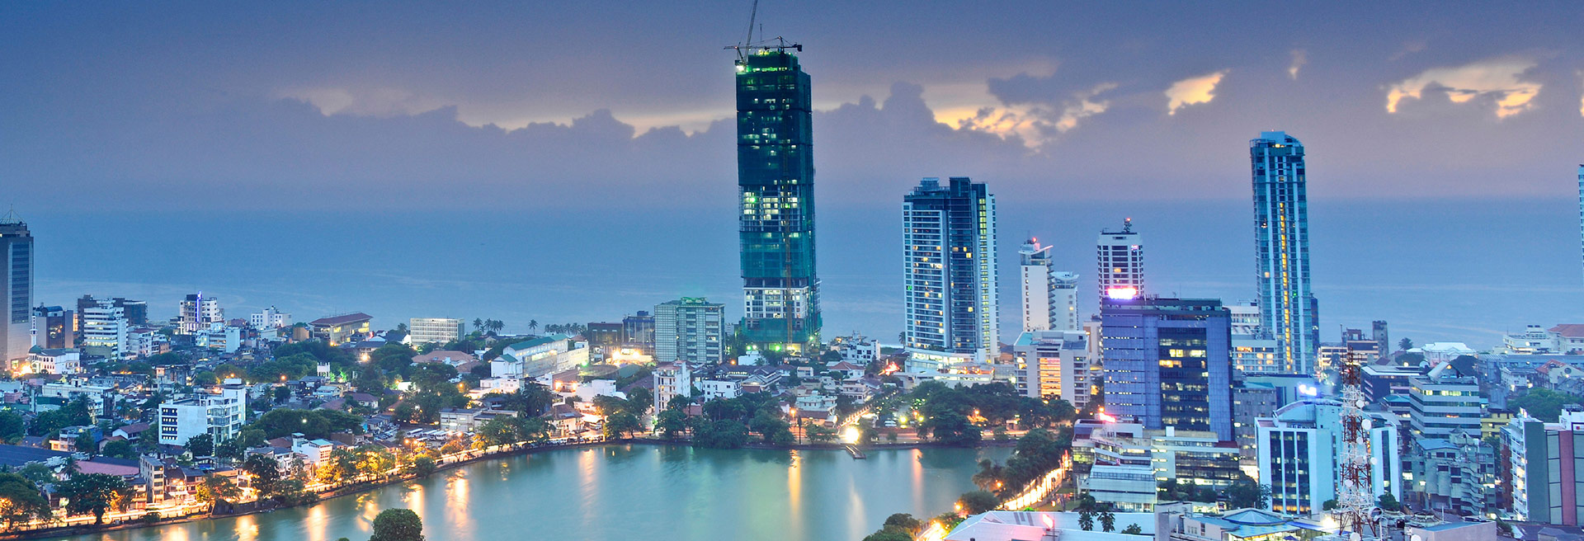Fly Back Home with Unforgettable Memories!!!!

Sightseeing

* Town Hall.
* Dutch Museum.
* Old Parliament.
* Independence Square.